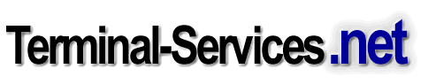

Customized Remote Desktop Connection Client
Technology Overview

By Cláudio Rodrigues
MCP, CNE, CNA, CCA
Microsoft Terminal Services MVP

Statement of Confidentiality
This document contains information, which may relate to the trade secrets of Terminal-Services.NET, or those of its suppliers, as well as financial, commercial, scientific, or technical information that is confidential to Terminal-Services.NET. Disclosure of such information may result in material or financial loss, or may prejudice the competitive position of Terminal-Services.NET and its suppliers. Accordingly, such information shall not be disclosed except to the employees of Terminal-Services.NET for the purpose of evaluation of this document.

Introduction

In a terminal services environment, users connect to a centralized server “farm” (one or more terminal servers) that provides either a full desktop solution or specific applications. This connection is established over TCP/IP, using the Remote Desktop Protocol (RDP).

Although the RDP protocol is encrypted to enhance security, it lacks a mechanism to prevent a user, using a valid username and password, to logon to the server farm when connecting from an unauthorized machine.

By customizing the original Remote Desktop Client (the new RDP5.1 compatible client preinstalled by default on any Windows XP Professional machine) and using a tool from the Windows 2000 Server Resource Kit, TSVER, administrators can now add an additional layer of security for their Terminal Server farms.

Overview

Two major customizations applied to the Remote Desktop Connection client were changing the version number (to any four digits) and, based on many requests from Terminal Server administrators worldwide, disabling the Close button to avoid users disconnecting their sessions, while showing them a customized message (Fig.1).

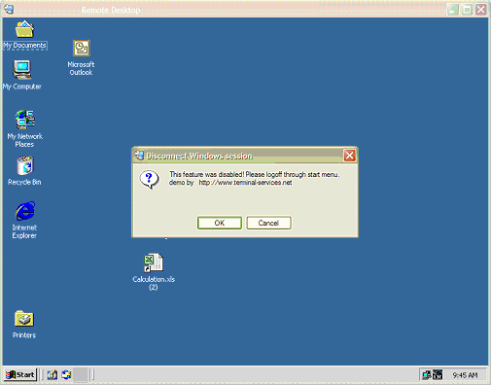

Fig.1

The new build version we assigned for this test was 3333 (see Fig.2), while the regular Remote Desktop Connection client shows build number 2600.

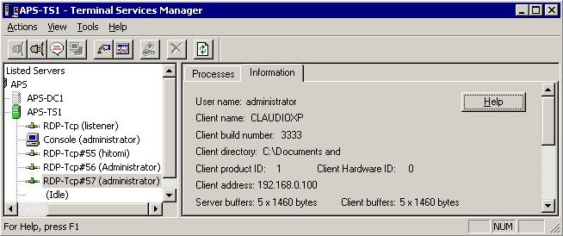

Fig.2

By using the TSVER (Terminal Services Version Limiter) utility from the Windows 2000 Server Resource Kit, you can restrict, at the server level, which Terminal Services client versions are allowed to run (Fig.3).

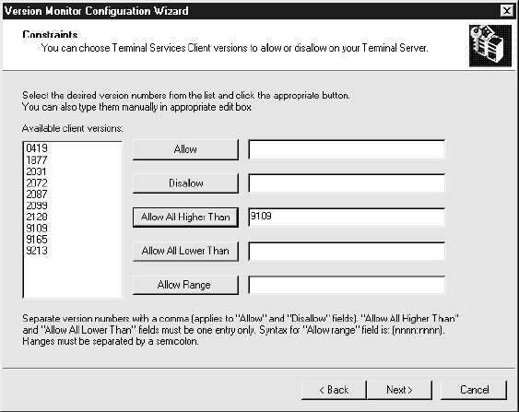

Fig.3

As shown in Fig. 3, you can allow or disallow specific version numbers or ranges of numbers. In the subsequent screen of the utility, you can specify that a customized error message be sent to the client in the event they attempt to connect with an unapproved client version. An event containing the customized message (if defined), client station name, and IP address is written to the System event log. This allows you to monitor any users attempting to connect to the Terminal Server using unapproved clients. A simple filter on the Event Viewer can display connections made by unauthorized users in the event you distribute a custom-built client to them.

To ensure TSVER is working properly, remember to copy the related Dynamic Link Library (DLL, tsver.dll) file from the Windows 2000 Server Resource Kit directory to all your terminal servers in the %systemroot%\system32 folder.

Conclusion

By using a customized version of the Remote Desktop Client, you will also be employing the latest RDP client available while controlling user access to the terminal server, even if they use a valid username and password. This is very important if a terminal server is accessible from the Internet. In addition, this version prevents users from inadvertently disconnecting a session if a user clicks the Close button.

If you have any comments or questions about this article, e-mail the author at claudio.rodrigues@terminal-services.net.

About the author

Microsoft MVP Cláudio Rodrigues is a senior server-based computing architect who has been involved in integrating computer technologies in Brazil, the United States, Europe, and Canada for more than 11 years. He currently leads Terminal-Services.net where he developed the only Terminal Services Client for the DOS platform available in the market, and is a co-owner of MC3 Digital Solutions Inc., a company providing consulting services across North America.

